Third Grade Curriculum

Third grade is a year filled with wonderful learning experiences and immense growth in your child’s interests, abilities, and academics. We work hard to expand and modify the curriculum in order to meet the needs and interests of our students. We also attempt to make our areas of study interrelated and enjoyable.
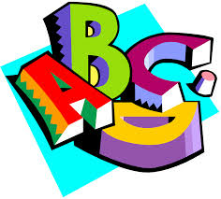 Language Arts

The third grade Language Arts program is aligned with the Common Core Sate Standards. We use a variety of approaches to build the skills necessary for success in reading and writing. The children will participate in Reading Workshop every day. The goal is to guide the children through many different reading strategies and literacy experiences in order to help them become independent, lifelong readers and writers. Children will be reading independently, in partnerships, as well as in guided reading groups.
Writing Workshop is taught through a process approach, which includes writer’s notebooks, planning, drafting, editing, revising and publishing. Each student will be expected to complete writing pieces in a variety of genres.
The third grade students are participating in a wonderful phonics program called Fundations. Third graders use Fundations to provide a systemic and explicit approach to reading and spelling with phonics. Fundations instruction emphasizes phonemic awareness, phonics word study, high frequency word study, fluency, vocabulary, cursive and spelling. Students have had experience using Fundations in Kindergarten, first and second grade and many of the protocols, strategies and procedures will remain the same this year.
Students will become acclimated to the expectations of the common core learning standards through Engage NY English Language Arts Modules and the NY Ready curriculum. These programs provide exposure to complex and authentic fiction and nonfiction texts in a variety of genres. Students will learn to respond to literature in writing using details from the text to support their thinking and making inferences about what they have read. These curriculums also help prepare the third graders for the NY state tests in the spring. If you would like to access sample questions and reading passages please visit EngageNY.org.
- The children will also participate in rich class discussions and reading activities using the Scholastics Storyworks magazine. This magazine is designed to meet the ELA standards by providing students with complex texts in a variety of genres. The magazine includes fiction, nonfiction, poetry, debates, plays, myths, classic literature, history and current events. Storyworks combines interesting complex texts with rigorous support materials to build the skills your students need. Students will occasionally be assigned homework using texts and resources from this magazine.

Math

The mathematics curriculum in third grade is based on the Primary Mathematics program, developed in Singapore. The program features a balance of problem solving, computational skill development, and mental mathematics. There is a strong emphasis on place value understanding in third grade, in addition to operations with whole numbers. Students learn multiplication and
division facts through 10, and are expected to know them by the end of the year. Additional units of study include data, measurement, money, fractions, time and geometry.
The Primary Mathematics program emphasizes reasoning and mathematical communication. Students are frequently recording and explaining their thinking to others in the class using mathematical language. This will help the students prepare for the math state test in the spring.
Social Studies

In third grade the children begin to learn about communities and people around the world. We start in our own country and then the children will be introduced to a variety of nations within our global community. Communities that will be studied in depth this year include the United States and China. The students use their new Social Studies knowledge to write informative, nonfiction articles and create digital presentations. Students will also learn map skills include cardinal and intermediate directions, using a map legend, identifying continents and oceans, locating places on a map, and identifying landforms.
Science

The third grade science program includes units of study in various disciplines of science that are also connected to many reading and writing experiences. Using the scientific method, the children will observe, explore, predict, experiment, and record their data through a variety of hands-on activities. Units covered in third grade include Properties of Water, Earth Materials, Life Cycle of Butterflies, and Frog Adaptations.
Within our study of Water, the third graders focus on interesting concepts such as surface tension, temperature, water density and the water cycle. Our Earth Materials study focuses on the difference between rocks and minerals and includes many interesting hands-on experiments that turn us into geologists! The favorite science study by far is Butterflies! The students each receive their own caterpillar and make observations as it goes through its life cycle and emerges as a butterfly! Frog Adaptations is a new interdisciplinary unit this year where students will be placed in research groups to become frog experts!

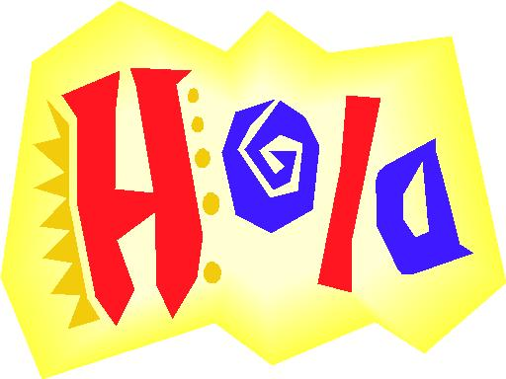 Springhurst FLES Program
The Spanish FLES curriculum for third grade is a sequential model in which all students receive 15-minute sessions daily. FLES instruction is proficiency-oriented with a greater focus on meaningful communication than on grammatical structure. Students are encouraged first to understand and then to produce in the language. Using an immersion approach, similar to the way children learn their first language, students participate in language training activities that are geared to the child’s interest level and include experiences with cultural practices and integration of thematic content. These experiences emphasize listening, speaking, reading and comprehension in meaningful, communicative contents: social/cultural situations, games, songs, and rhymes in addition to experiences with arts, crafts, movement and total physical response. Each lesson lays the foundation for the next and children gain confidence in listening and speaking. As they follow the sequential FLES curriculum each year, they progress to reading and writing in the target language.
Homework

Reading for 20 minutes each night is expected. You may read with your child, to your child, or have your child read alone. It is important that you talk about the content, share your response and reactions with your child, and encourage your child to talk about what was read. Please make nightly reading a priority in your home.
Math, Fundations, and ELA homework will be given on a weekly basis. The purpose of these assignments are not only to practice concepts we are working on in class, but also to help foster time management, responsibility and organizational skills in your student. Please set aside a quiet time and place for homework. Allow your child to work independently as much as possible and then review the homework with them once it has been completed. Your interest in your child’s work is a very important component in the beginning development of good work habits and a positive attitude.
Communications

The third grade teachers are always available via email during the school week. Please make sure that your child’s teacher has your up-to-date email address! Students will bring home important notes and information in their Homework folder each day. Please make sure to go through these notes and handouts each day.
*If your child’s dismissal plans changes throughout the school day please remember that teachers need to be notified of all changes in transportation by way of a note/email from you AS WELL AS A PHONE CALL TO THE MAIN OFFICE. We are always available to discuss any thoughts, questions or concerns you may have as the year progresses.
We look forward to a wonderful year with your child!

